**Please add the Add-on file (ojdbc6.JAR) into the library and add new connection to connect.**

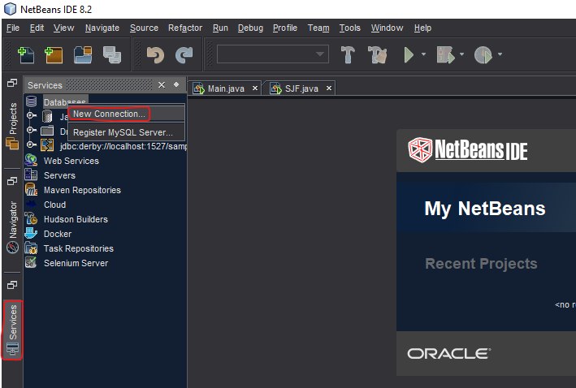**STEPS:**

1. **.**
2. **Driver (Oracle Thin)… Add (ojdbc6.JAR)**

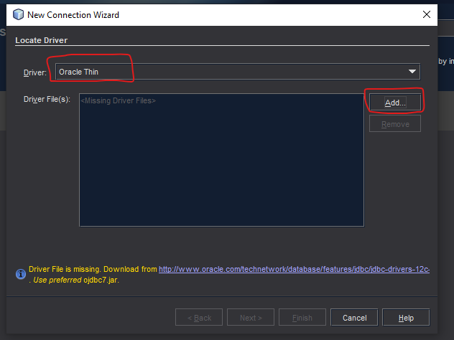

1. 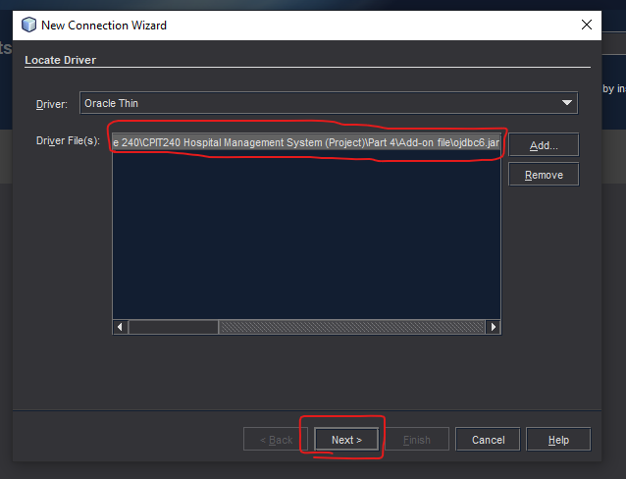**Select the Driver File then Next.**

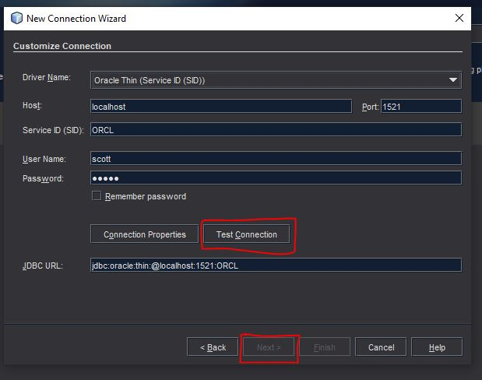

1. **Enter Host, Port, Service ID, User Name, and password WHILE Connected to SQL PLUS, then Test Connection, then Finish.**

**(NOTE: Host, Port, and Service ID may differ)**



1. 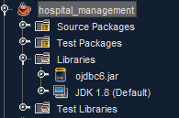**Add Add-on file (ojdbc6.JAR) in the following location.**

**If connection is successful, then the program should run safely.**

**If not (maybe due to the NOTE), then do the following**

1. **Follow the video (Duration 2 min):**

[**https://www.youtube.com/watch?v=-Ta3d7EdVQA&t=23s**](https://www.youtube.com/watch?v=-Ta3d7EdVQA&t=23s)

1. 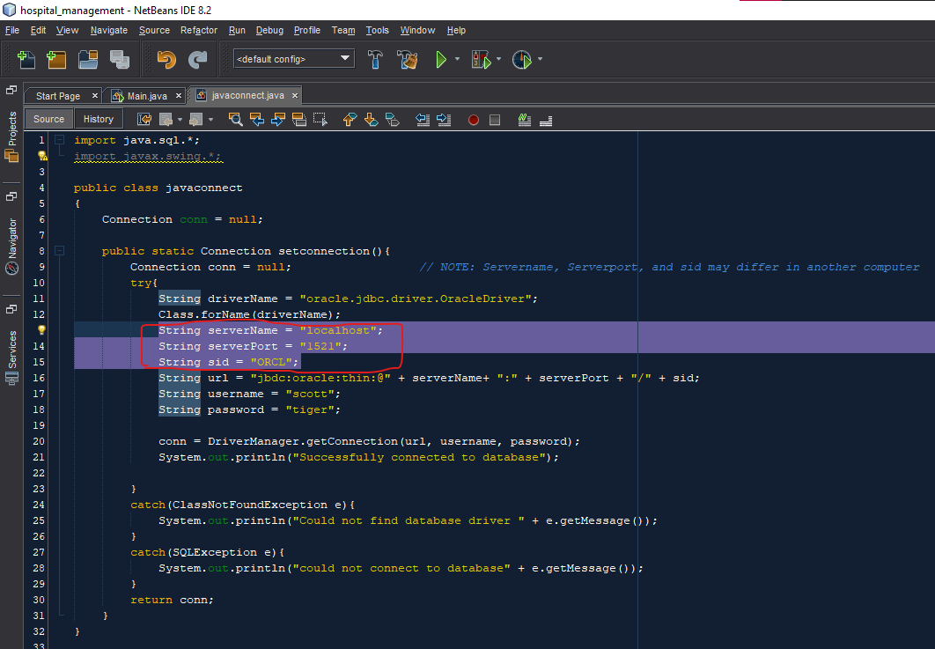**Then edit information in javaconnect.java according to your Host, Port, and service id (can be known through video).**

1. Graphical user interface, application

   Description automatically generated**Add Add-on file (ojdbc6.JAR) in the following location.**

**Thank you for your Patience.**